**Deploy MVC on Virtual Machine inside Virtual Network**

1 Create a virtual network with 2 subnets. Each subnet should have 16 Ips only.

**Creating Virtual Network**

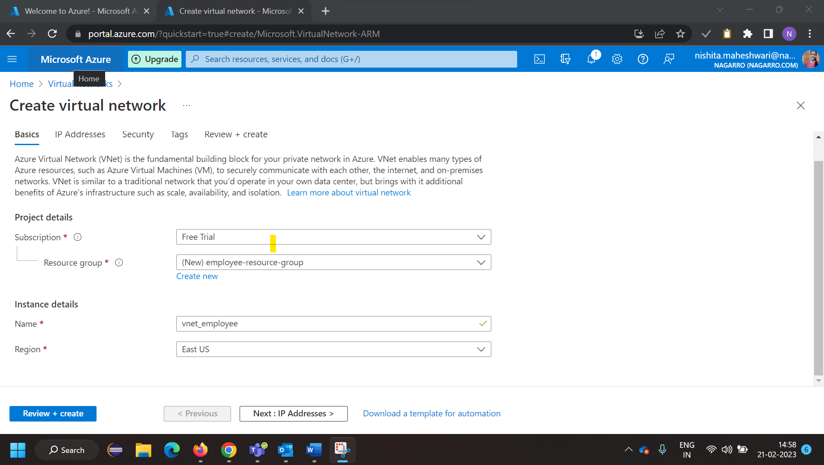

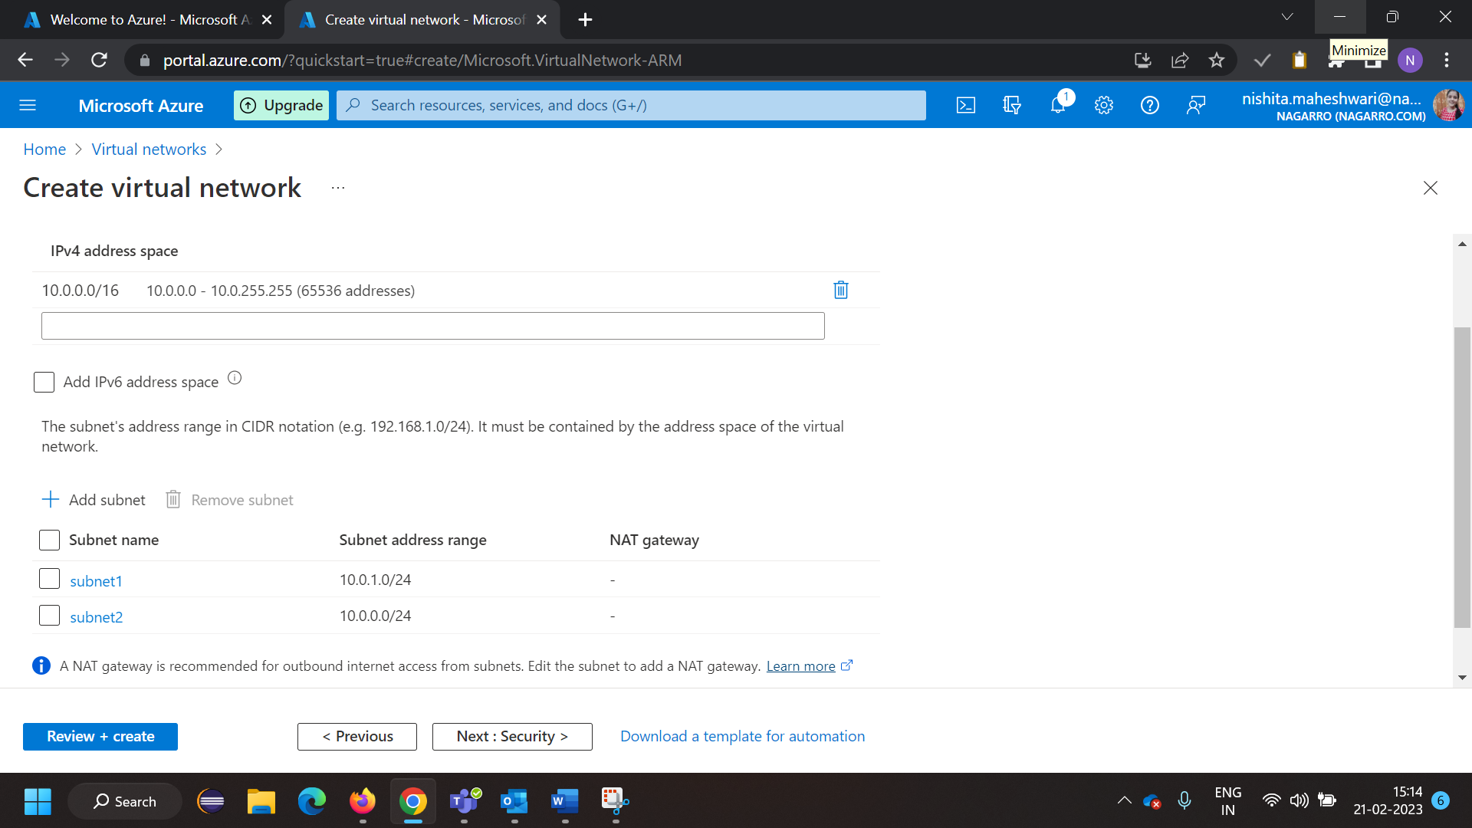

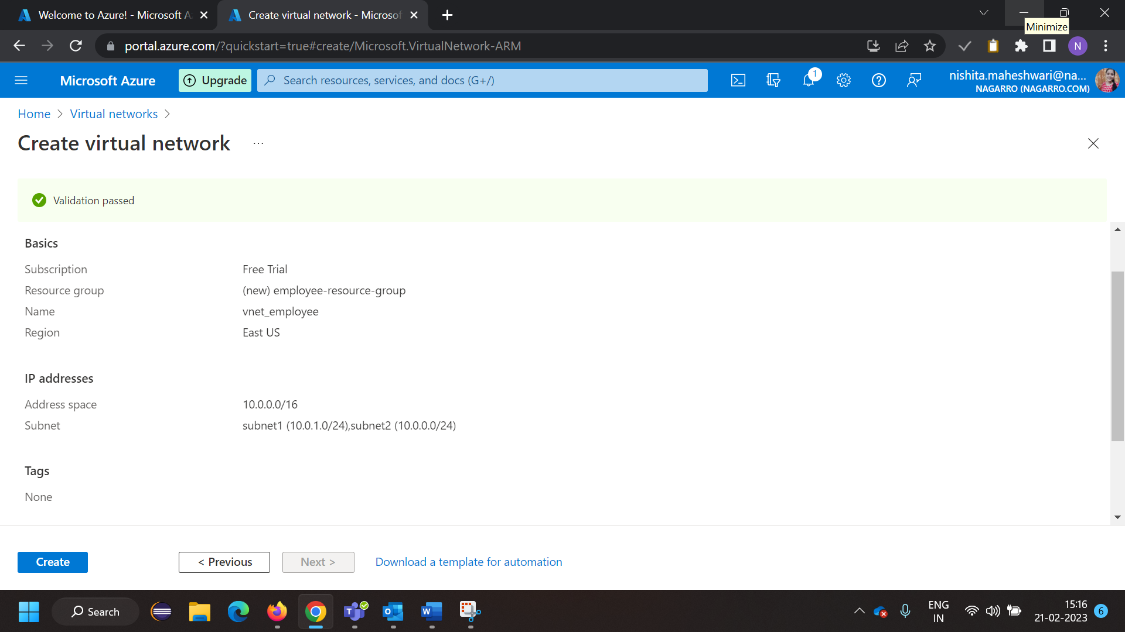

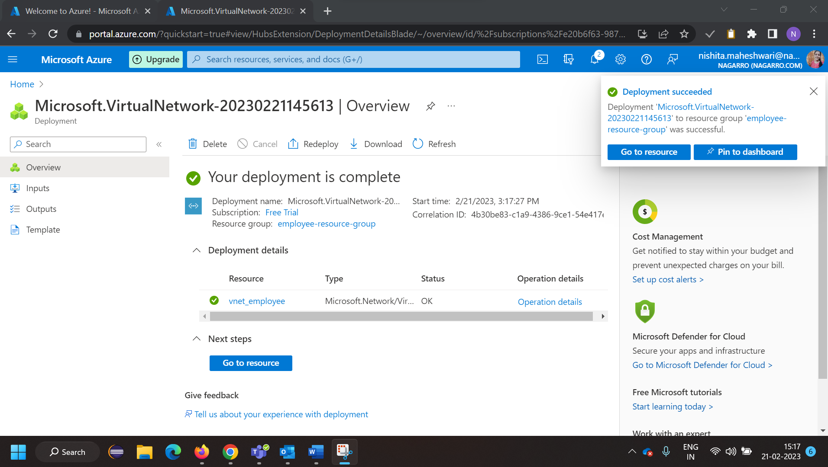

**Creating Virtual Machine**

Inside one of the subnets, create a VM and deploy an application code inside it and it should  
leverage the database on the cloud (any existing application created by you before).

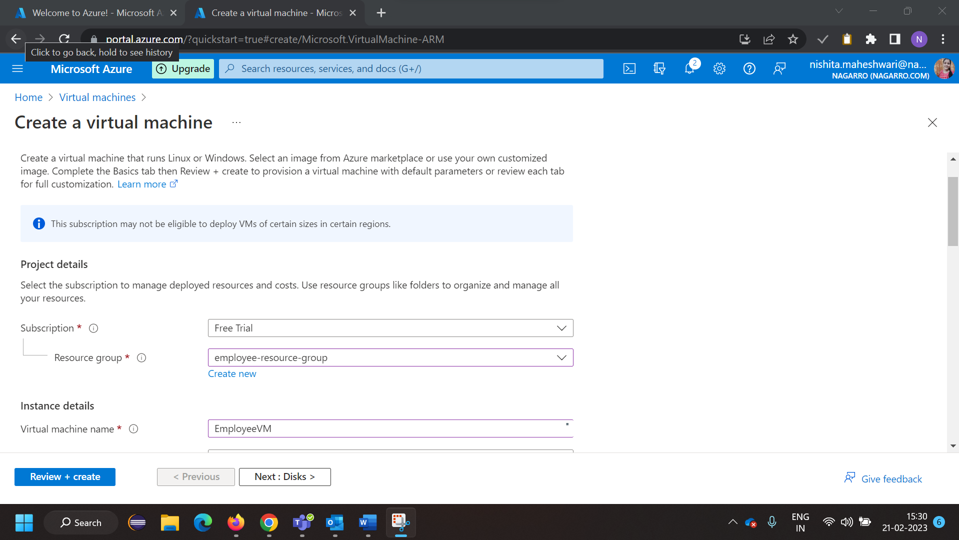

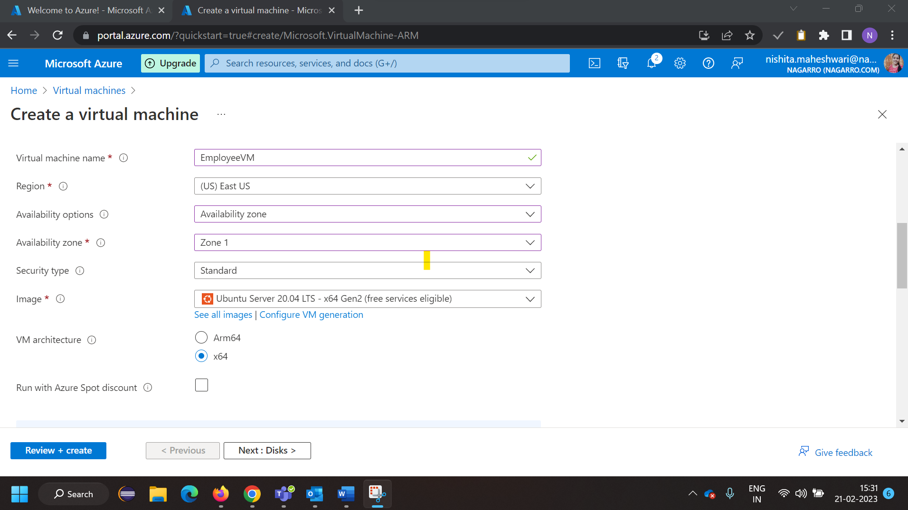

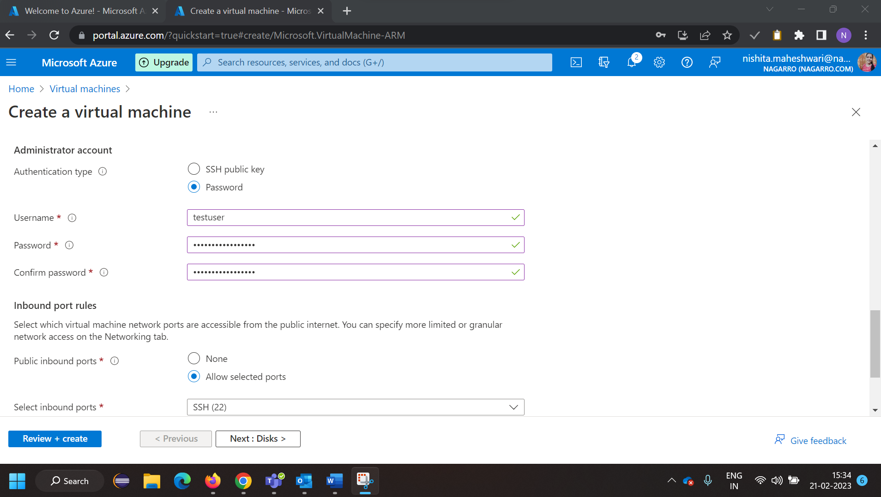

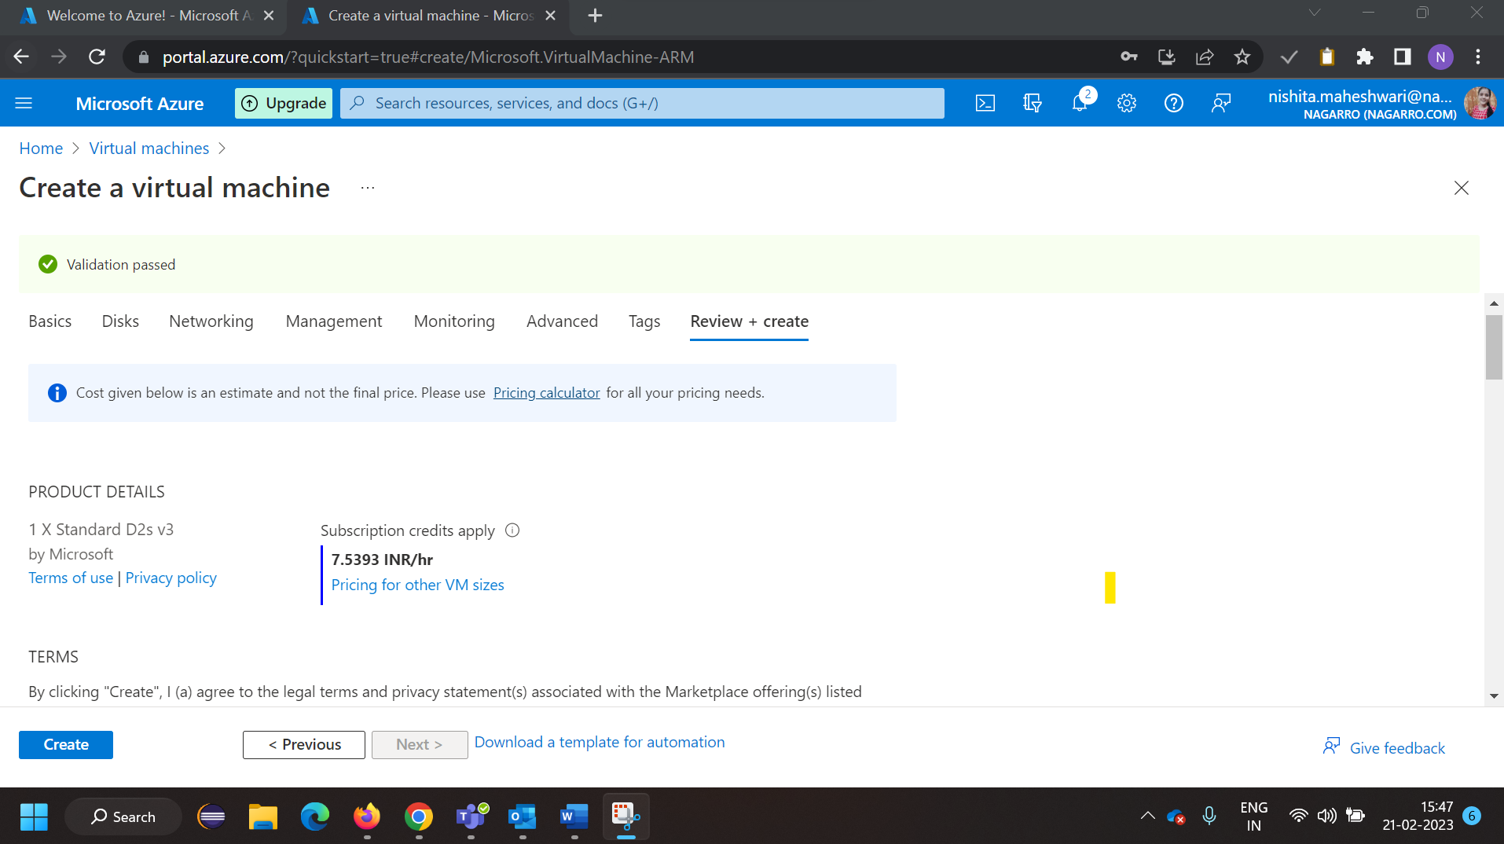

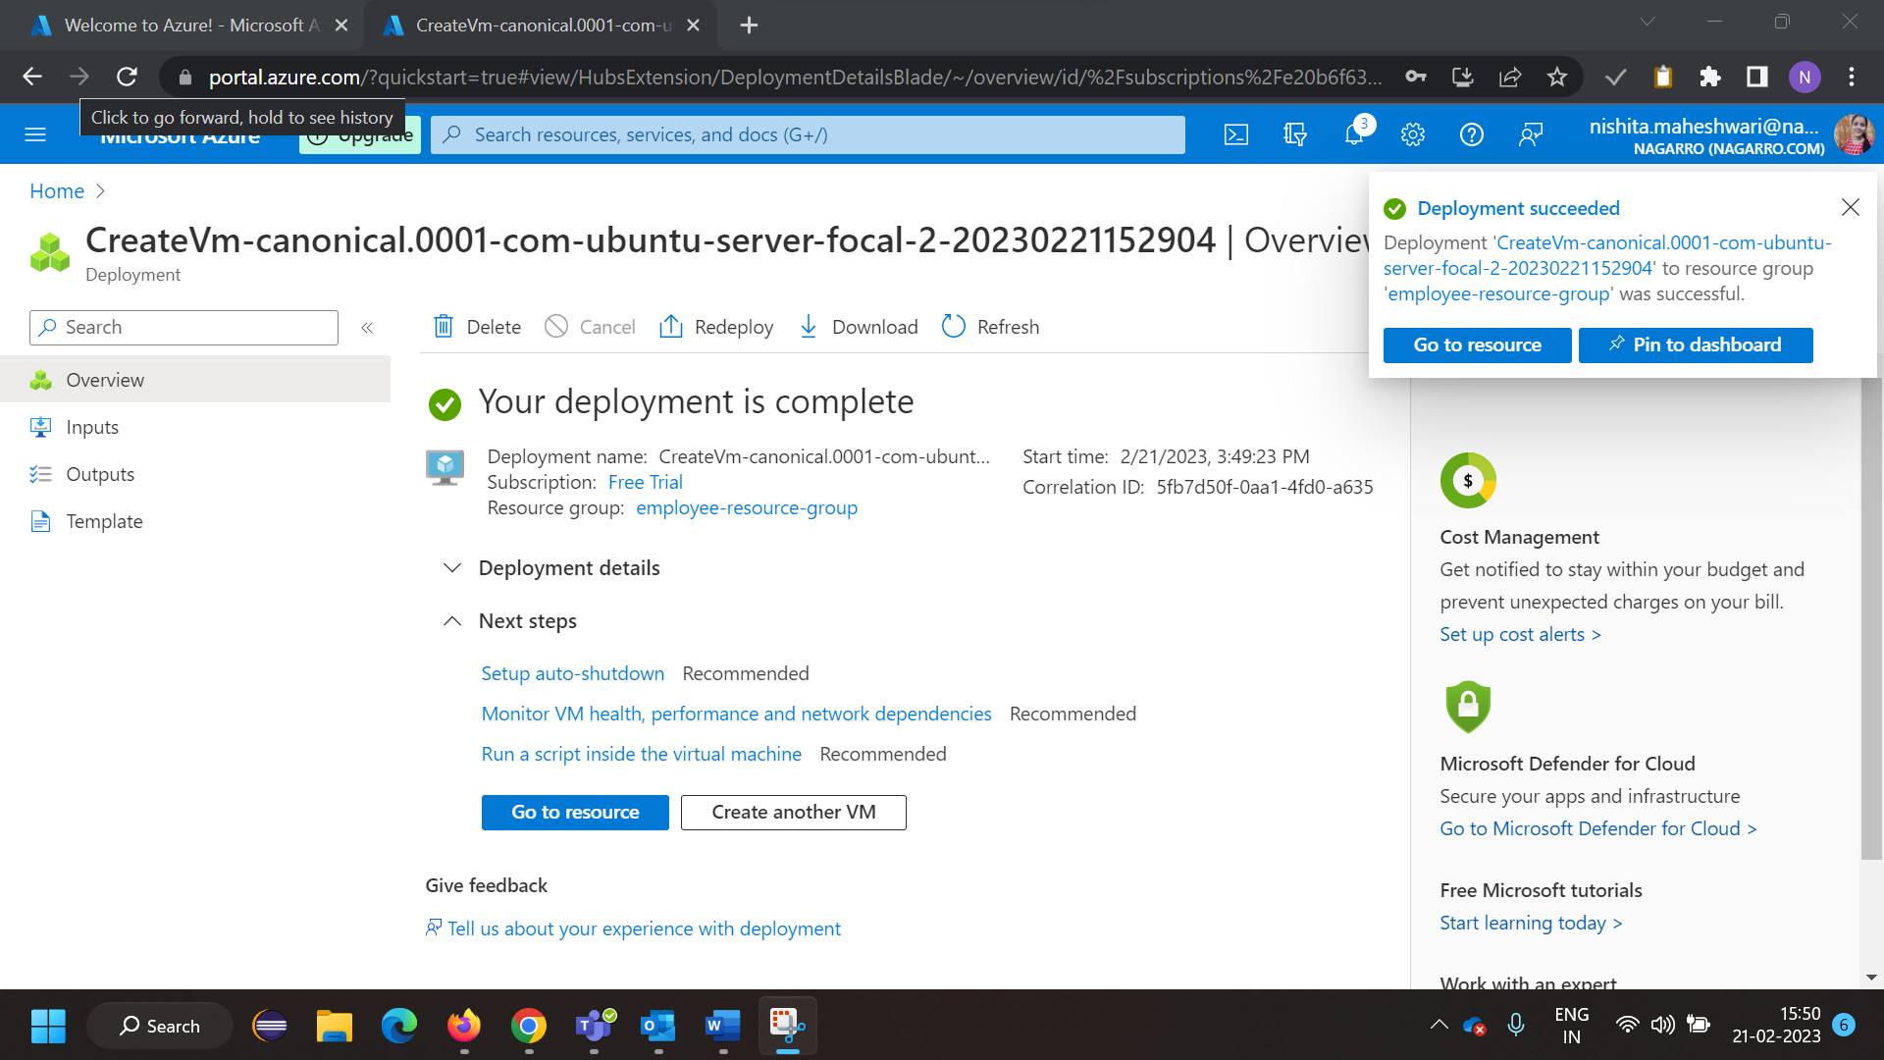

Creating SQL Database

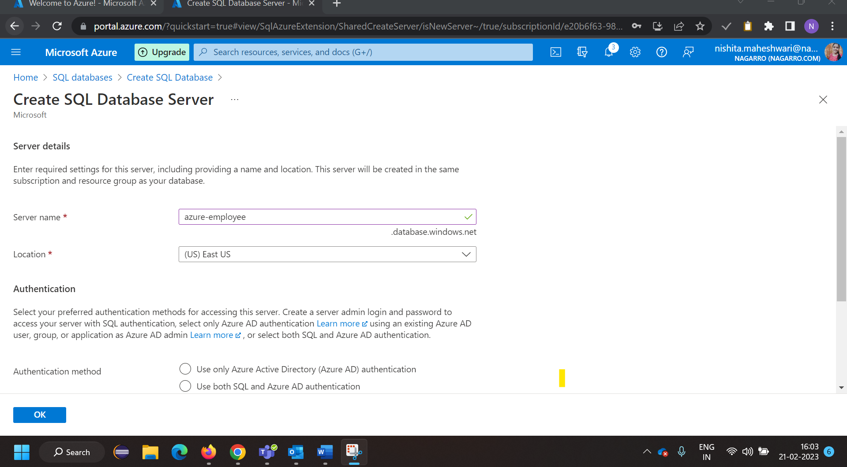

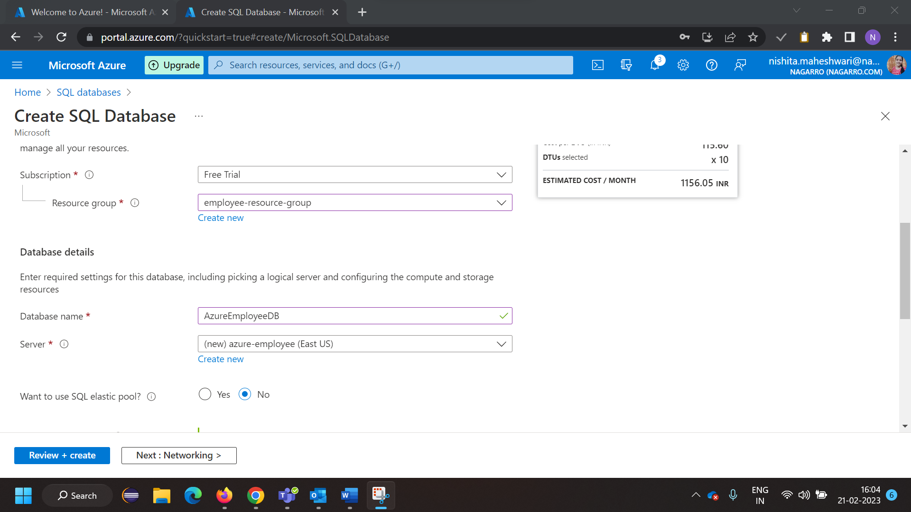

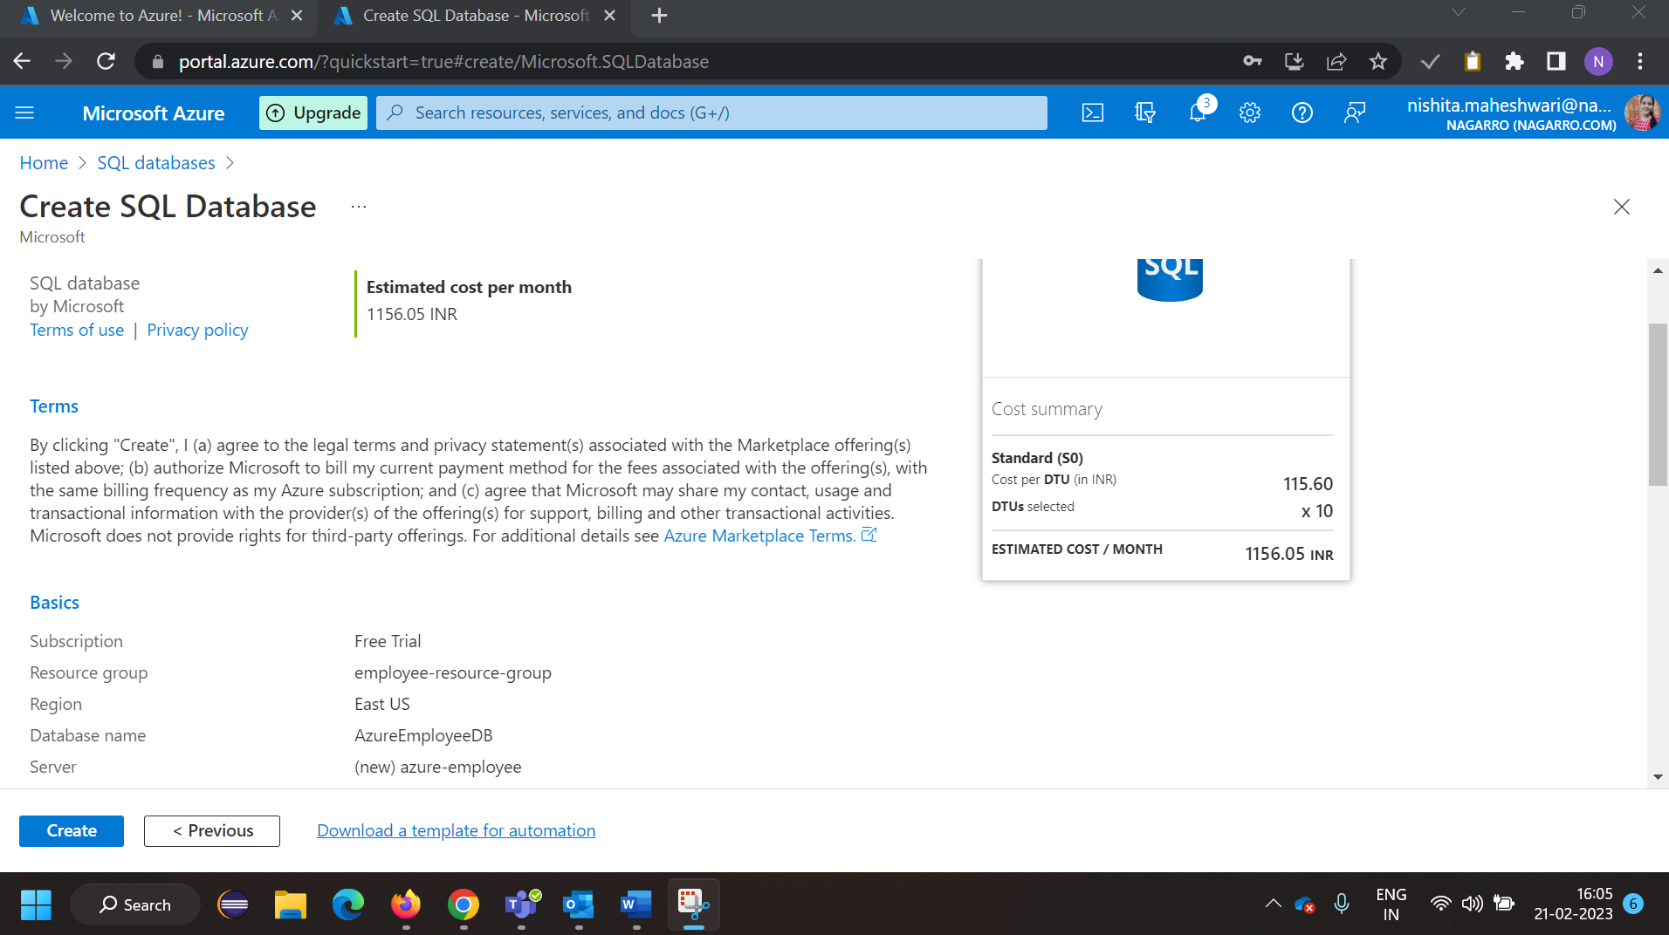

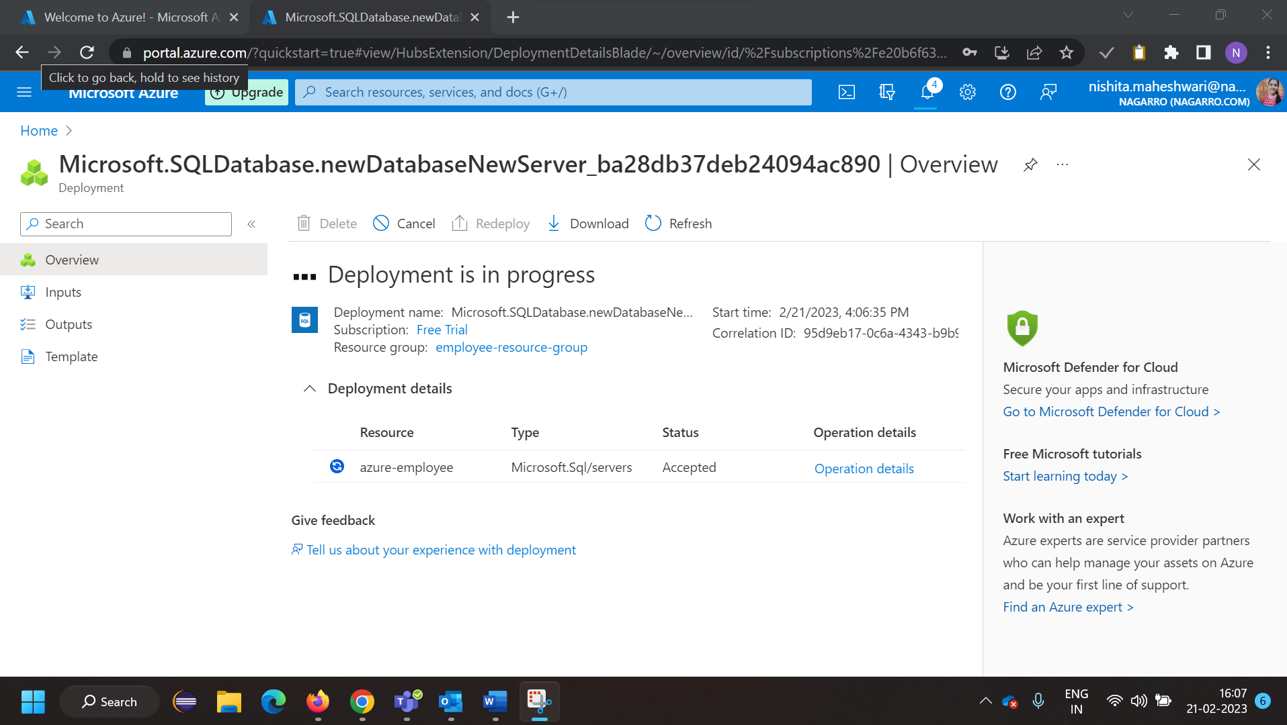

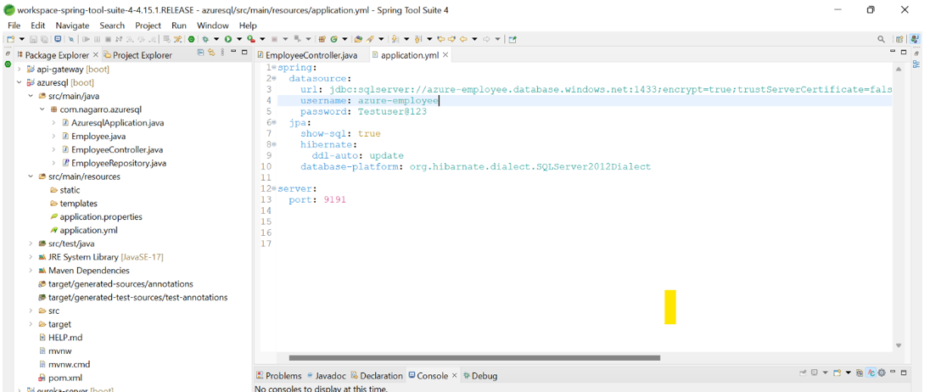

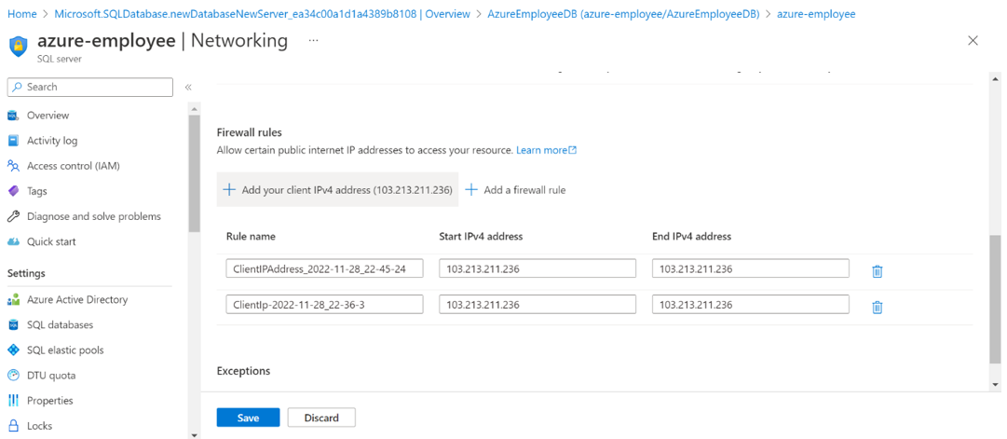

Deploy the same application to Azure App Service. It should also leverage the database on  
the cloud.

**Create App Service**

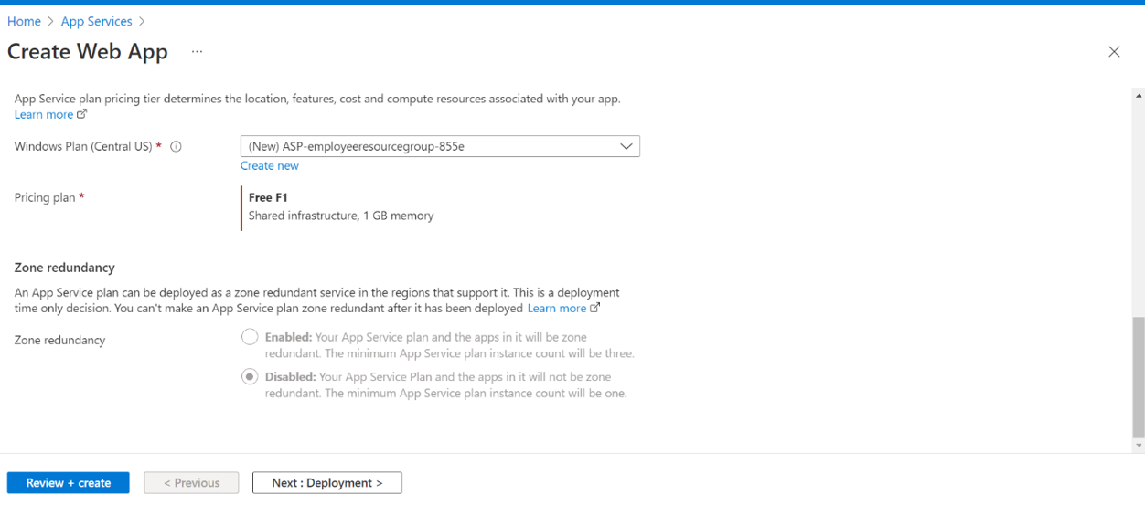

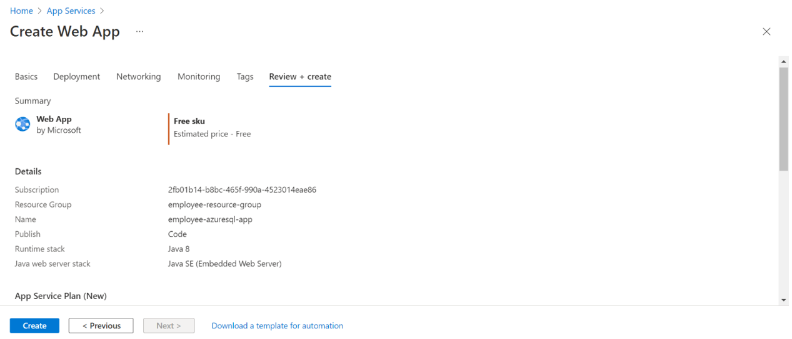

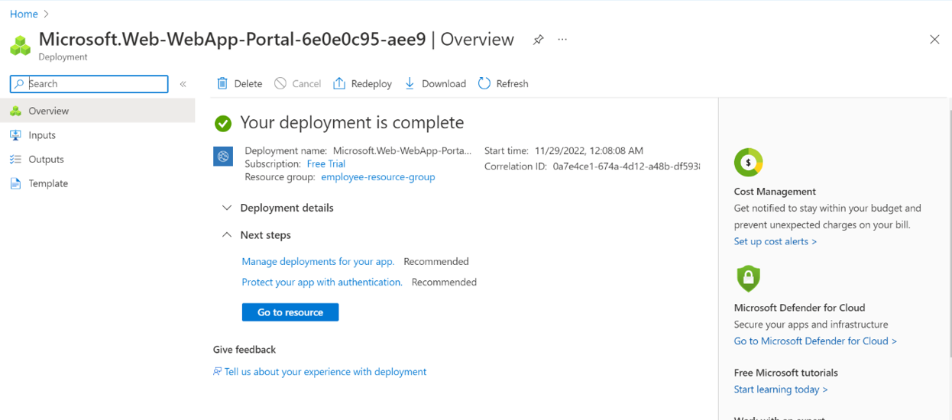

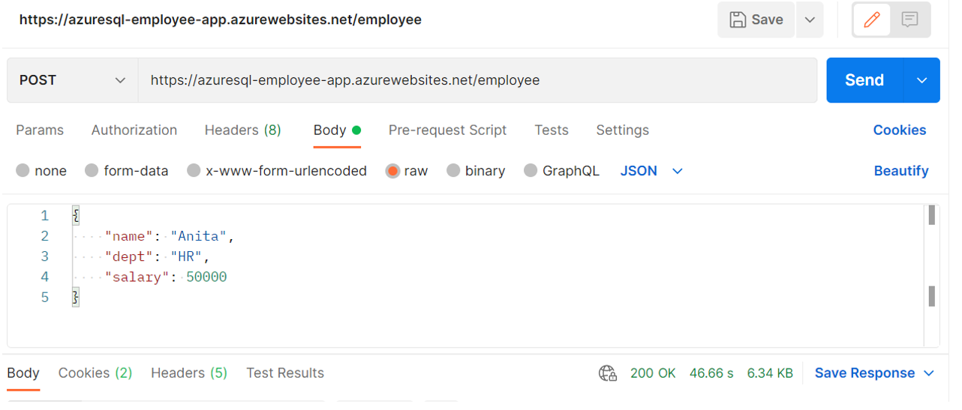

**AKS**

**Create Kubernates Cluster**

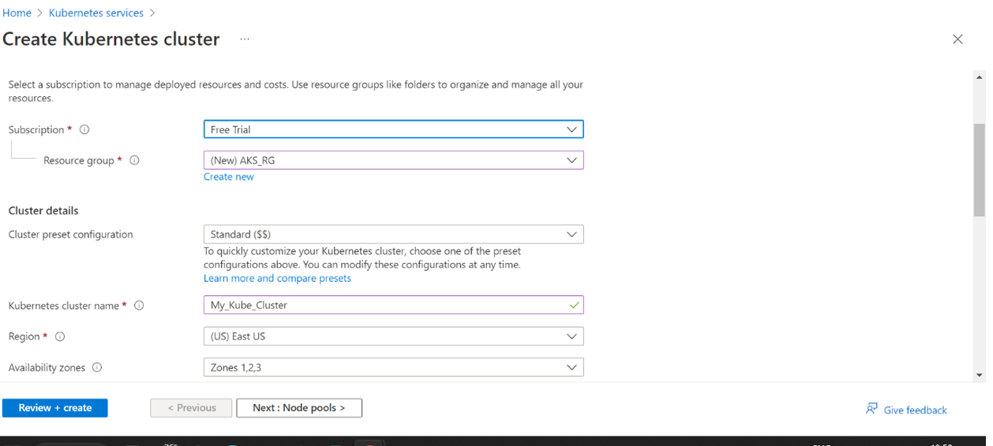

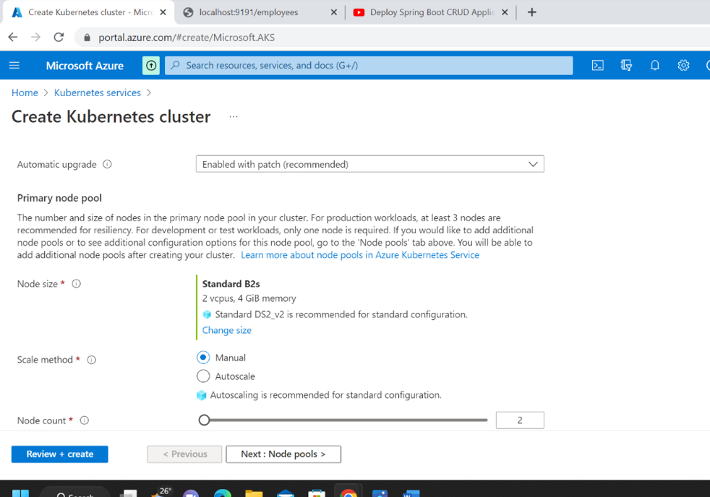

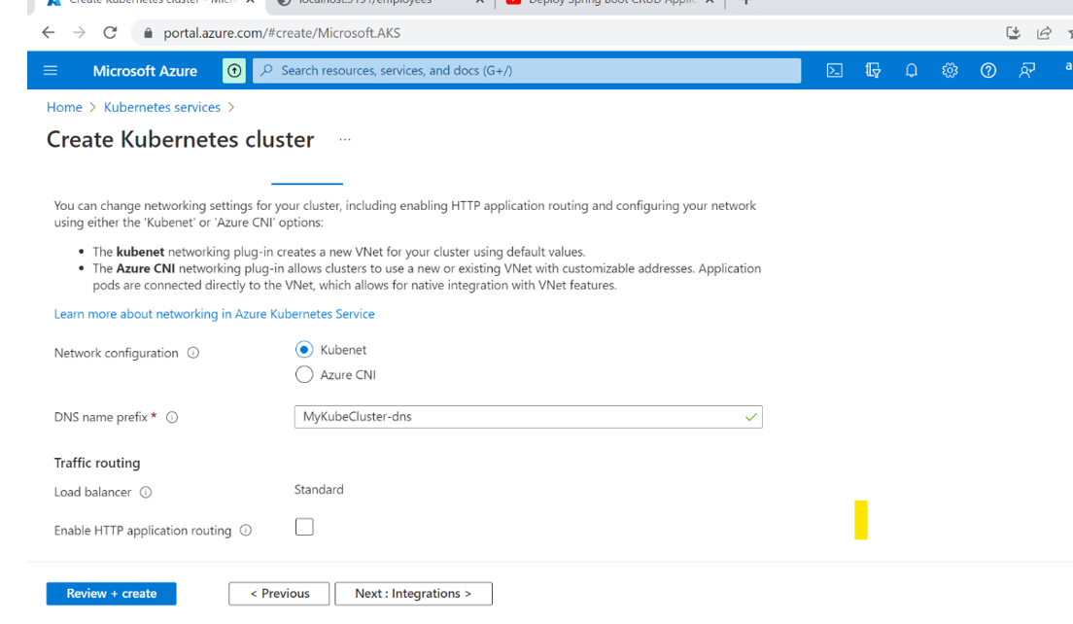

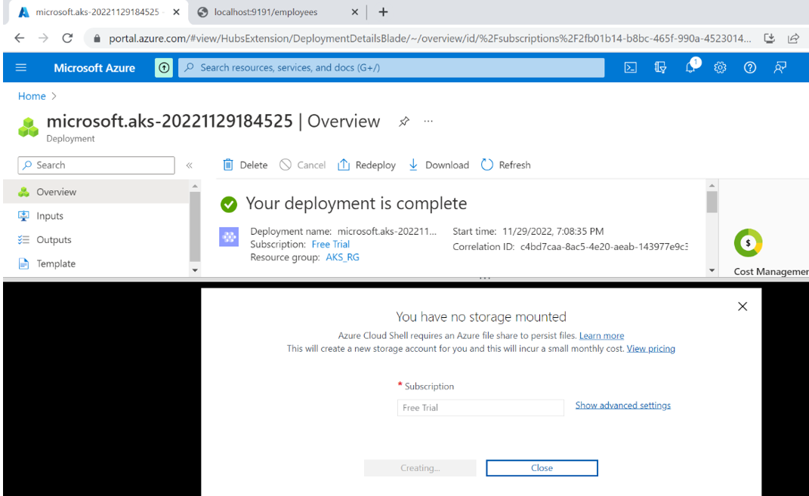

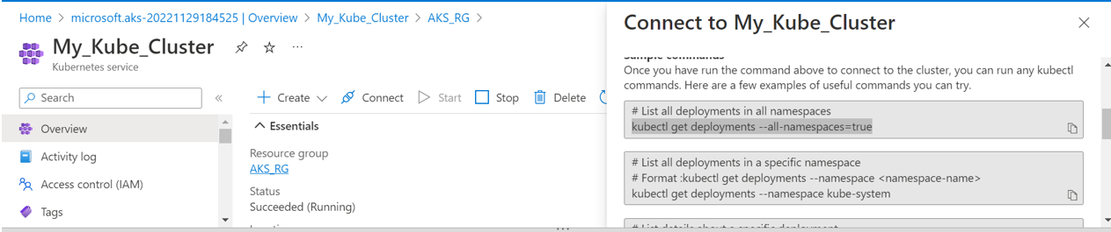

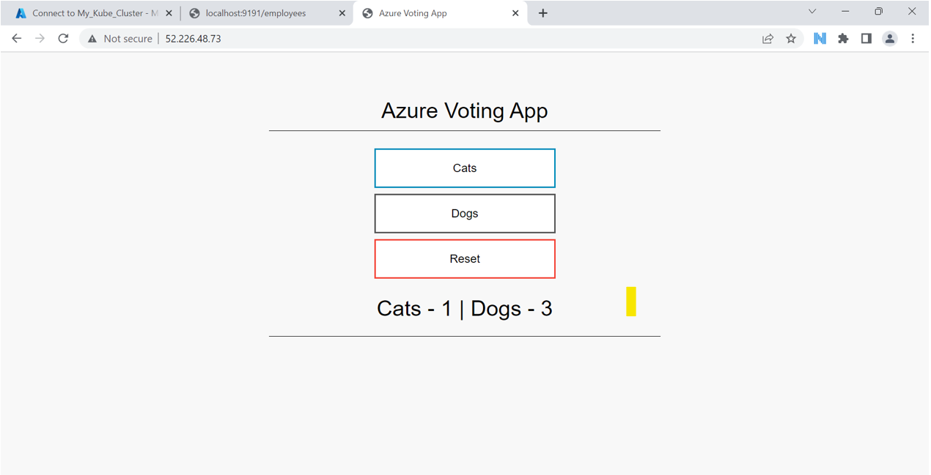

Create an Azure function that should trigger as soon as you upload a file in the blob storage.  
Function should be able to print the name of the file uploaded in the function.

**Azure Blob storage trigger using Azure Functions**



